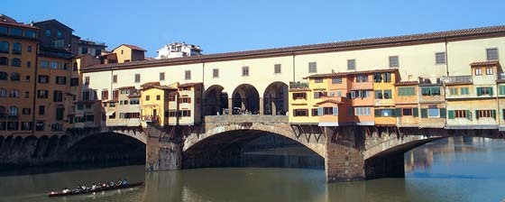

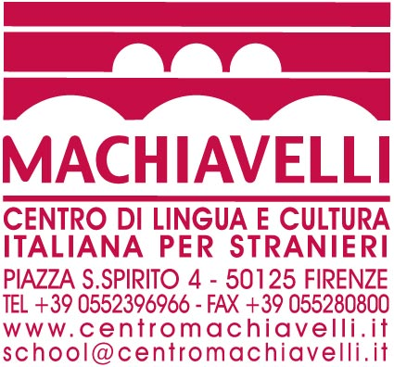

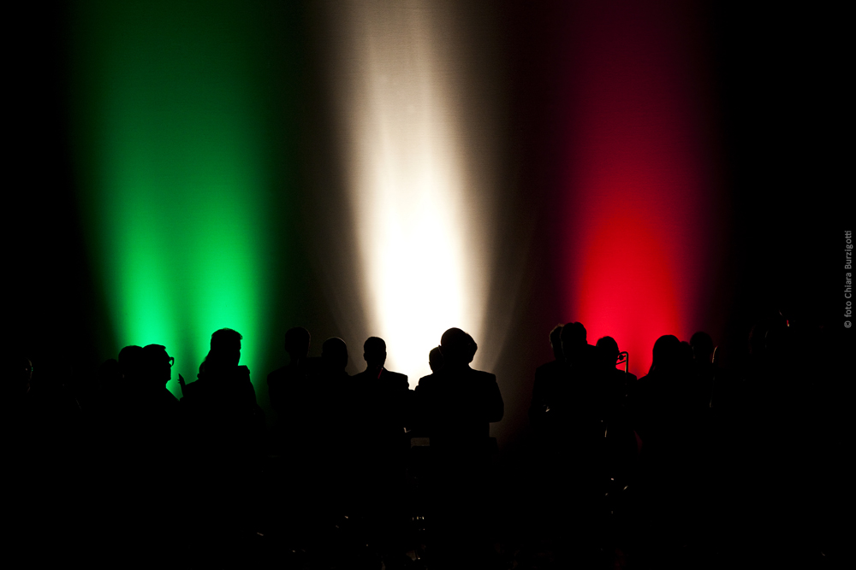
ANDIAMO IN ITALIA!
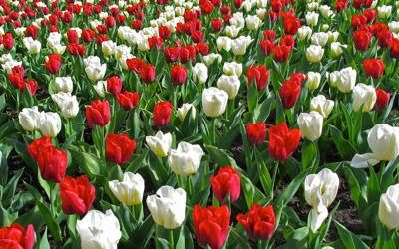

ITALIAN LANGUAGE AND CULTURE PROGRAM IN FLORENCE 2014
Dates: 22nd MAY – 7th June 2014
Arrival: 22nd May 2014 / Departure: 7th June 2014

Thursday 22nd May
Arrival in Florence and settle in accommodation
7:30pm meet in lobby of Gould Institute. Dinner
UC paid group dinner Osteria Santo Spirito 8:00pm

Friday 23th May
Free breakfast at Gould on second floor
10.30 am meet in lobby of Gould Institute. Bring your Uffizi pass.
11am tour San Marco
lunch on your own
meet outside door #2 of Uffizi gallery at 2:40pm

Saturday 24th May
Free breakfast at Gould on second floor
7:30 am: meet in lobby of Gould Institute. Be on time
8:10 am bus to Siena. Arrive 9:25am Siena
tour Siena: Sala della Pace and Cathedral with library
lunch on your own
depart: 6:20pm arrive 7:35 tickets 6,50 euro one way

Sunday 25th May
Free breakfast at Gould on second floor
10:30 am: meet in lobby of Gould Institute. Be on time
11am tour of Bargello
San Lorenzo market free time
1:45pm meet outside the entrance to the Medici Chapel in San Lorenzo market

Monday 26th May
Beginning of the Italian language classes (2 lessons)
Free breakfast at Gould on second floor every day
9am meet at Gould lobby
Bring cash for culture 204 euro (exact change)
Classes begin 9:20am to 1:30pm with a break
3:45pm meet outside entry to Duomo museum

Tuesday 27th May
Free breakfast at Gould on second floor
Classes 9:20am to 1:30pm
1:45pm meet outside entry to Baptistery next to Duomo
UC paid group dinner 8pm

Wednesday 28th May
Free breakfast at Gould on second floor
Classes 9:20am to 1:30pm
3pm meet by Dante statue in front of Santa Croce
tour of leather works in back, shopping
3:45pm return to Dante statue for tour of Santa Croce complex

Thursday 28th May
Free breakfast at Gould on second floor
Classes 9:20am to 1:30pm
Purchase 1 ticket for bus at tabaccheria next to Machiavelli
Take bus 12 or 13 to San Miniato for 5pm tour.
Meet outside church doors.
You can walk down or take bus back.
There is a pretty evening service at 5 or 6pm at San Miniato. Tour old cemetery.

Friday 29th May
Free breakfast at Gould on second floor
Classes 9:20am to 1:30pm

FREE WEEKEND from Friday after class thru Saturday, Sunday to 2nd June
If you plan on leaving Florence, fill out a student away form. (see Prof M)
Free breakfast at Gould on second floor for those who stay

Monday 2nd June
Free breakfast at Gould on second floor
National Holiday, no school
5:15 pm Meet in Piazza Mentana for Boat Tour Renaioli

Tuesday 3rd June
Free breakfast at Gould on second floor
Classes 9:20am to 1:30pm
3:45pm Pitti Palace meet at the entrance

Wednesday 4th June
Free breakfast at Gould on second floor
Classes 9:20am to 1:30pm
7:15pm Meet in Gould lobby
In Tavola Cooking and eating
Via dei Velluti, 18

Thursday 5th June
Free breakfast at Gould on second floor
Classes 9:20am to 1:30pm
4:15pm Accademia: The David
UC paid group dinner 8pm

Friday 6th June
Free breakfast at Gould on second floor
Classes 9:20am to 1:30pm

Saturday 7th June
Departure

